Initial HealthConnect Analytics Report
HealthConnect Clinic — Data Analytics Track
AnalystLab Africa Experience Lab — Week 5
Prepared by Oluwatosin Olusanya, Data Analyst — AnalystLab Africa

1. Week 4 → Week 5 Transition
Week 4 established that HealthConnect Clinic faces a 48.5% no-show rate, confirmed the dataset was clean and analysis-ready, defined 6 business questions, and proposed 5 KPIs without calculating them. This week moves from that plan into actual analysis: every proposed KPI below is now calculated against the real dataset, supported by exploratory analysis and visualisations, and translated into concrete business insights and recommendations.

2. Data Preparation Summary
The dataset (5,000 appointments) was re-confirmed clean per the Week 4 assessment: no duplicate records, no missing values in core fields, and no logical inconsistencies. Two small pockets of missing data remain (distance to clinic km: 1.8%, waiting time minutes: 1.2%) and were excluded row-wise only from the specific calculations that use those fields, rather than dropped from the dataset entirely. The original CSV was not modified; all analysis was performed on a copy. Appointments with outcome "Cancelled" (5.3%) were excluded from all no-show rate calculations, since a cancellation is a different behavioural event from a silent no-show — this decision, flagged as undecided in Week 4, is now made explicit and applied consistently throughout this report.

3. Exploratory Data Analysis
Analysis focused on how no-show likelihood varies across appointment characteristics, patient history, reminders, and contextual factors. The overall no-show rate across the 4,737 appointments with a definitive outcome (Attended or No-Show) is 51.2%.
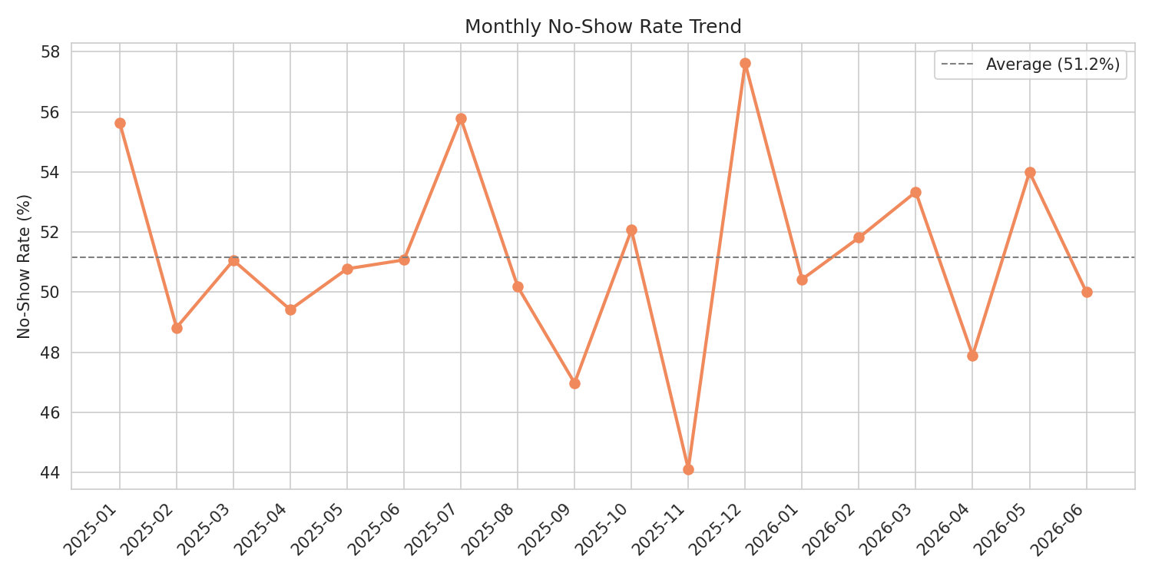
Figure 1: Monthly no-show rate trend.

The monthly trend fluctuates between roughly 44% and 58% with no strong seasonal pattern or sustained upward/downward trend — the no-show problem is consistently high throughout the period rather than worsening or improving over time on its own.

4. KPI Calculations
Five KPIs were selected from the six proposed in Week 4 and are now fully calculated below.
KPI 1 — Overall No-Show Rate
Definition: No-Shows ÷ (Attended + No-Shows)
Linked business question: What is the overall no-show rate, and how does it vary over time?
Why it matters: The baseline metric management needs to track whether any intervention is working.
Calculated result: 51.2% (2,423 of 4,737 definitive-outcome appointments). Monthly range: 44.1% - 57.6%, no clear trend.
Interpretation: Roughly one in every two scheduled appointments is missed. This is a severe, not marginal, operational problem, and it is stable rather than improving on its own.
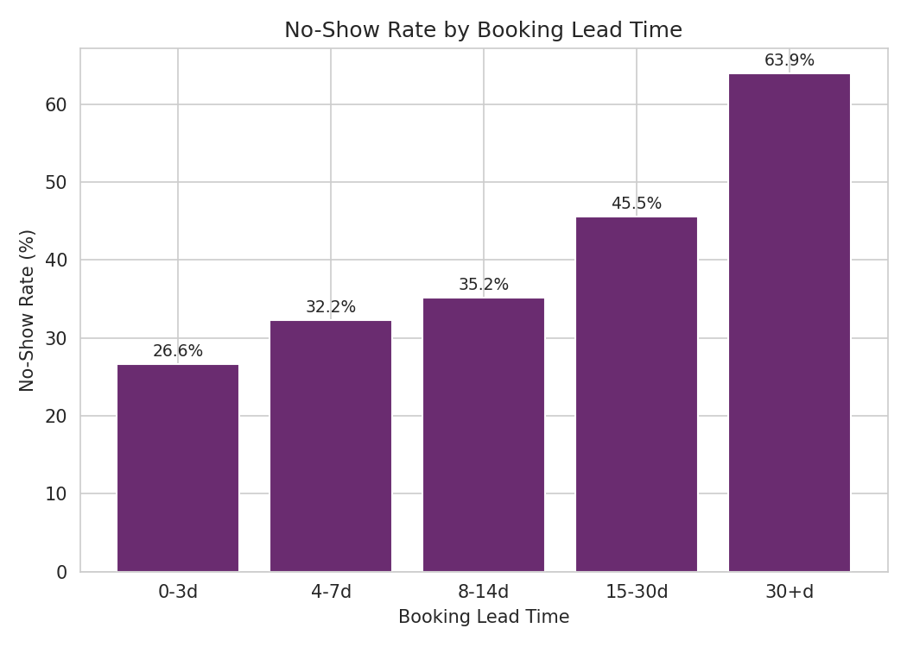
Figure 2: No-show rate by booking lead time.

KPI 2 — No-Show Rate by Booking Lead Time
Definition: No-show rate segmented into bands: 0-3, 4-7, 8-14, 15-30, and 30+ days between booking and appointment.
Linked business question: Does how far in advance a patient books affect attendance?
Why it matters: Identifies whether scheduling policy itself (how far ahead patients’ book) is a controllable lever.
Calculated result: 26.6% (0-3 days) rising steadily to 63.9% (30+ days). Correlation with no-show: r = 0.287 (moderate, positive).
Interpretation: This is the strongest single behavioural driver found in the dataset. A robustness check (splitting by appointment type) confirmed the pattern holds independently within every appointment type — it is not an artifact of longer-lead appointments simply being a different kind of visit.
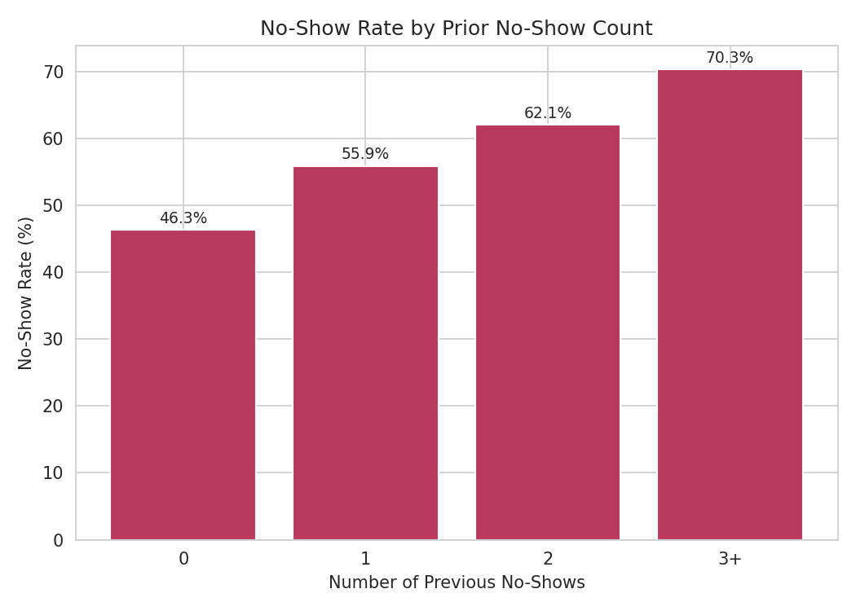
Figure 3: No-show rate by number of prior no-shows.

KPI 3 — Repeat No-Show Rate
Definition: No-show rate segmented by a patient's count of previous no-shows (0, 1, 2, 3+).
Linked business question: Does a patient's own history predict future no-shows?
Why it matters: Identifies a high-risk patient segment that could be targeted for proactive outreach.
Calculated result: 46.3% (0 prior) rising to 70.3% (3+ prior no-shows) a clear, escalating relationship.
Interpretation: Past behaviour is a strong predictor of future behaviour. Patients with 3 or more prior no-shows are missing appointments at a rate 24 points higher than first-time patients, making this a natural segment for a targeted confirmation-call or double-booking policy.
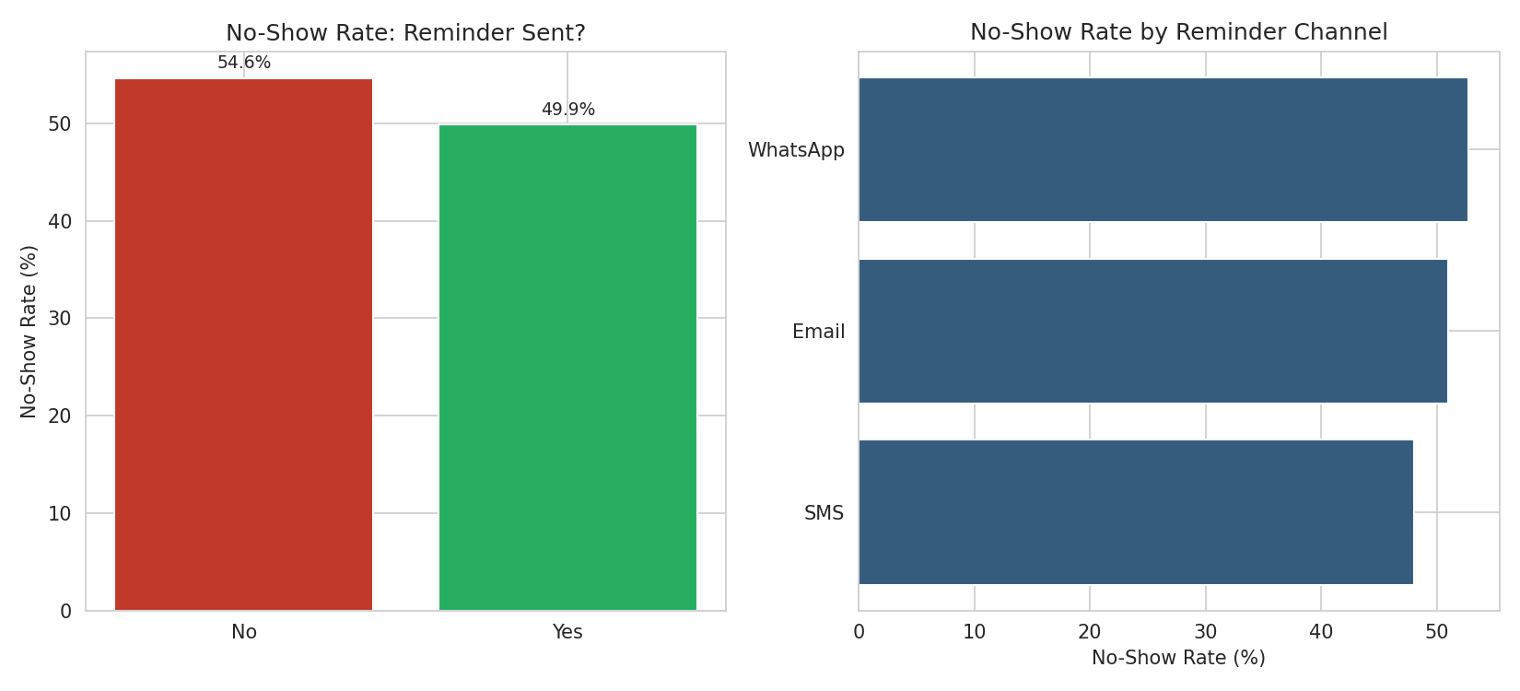
Figure 4: No-show rate by reminder status and channel.

KPI 4 — Reminder Effectiveness Rate
Definition: No-show rate compared across reminder sent (Yes/No) and across reminder channel (SMS, Email, WhatsApp).
Linked business question: Does sending a reminder, and which channel, reduce no-shows?
Why it matters: Directly actionable reminders are one of the cheapest interventions available to the clinic.
Calculated result: 49.9% (reminder sent) vs 54.6% (no reminder) a modest 4.7-point improvement. By channel: SMS 48.0%, Email 51.0%, WhatsApp 52.7%.
Interpretation: Reminders help, but the effect is far smaller than booking lead time or prior history. SMS modestly outperforms Email and WhatsApp. Reminders alone are not a sufficient fix, but remain a reasonable low-cost baseline intervention.
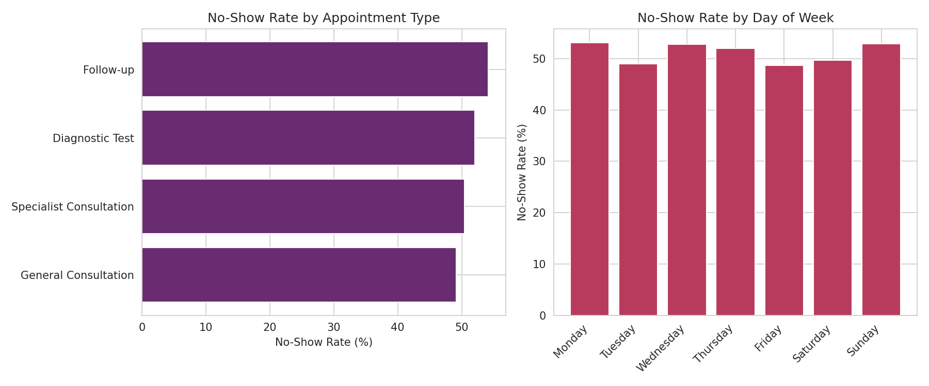
Figure 5: No-show rate by appointment type and day of week.

KPI 5 — Slot Utilisation Loss
Definition: Number and proportion of scheduled slots lost to no-shows, segmented by appointment type and day of week.
Linked business question: Which appointment types, days, or times see the most no-shows?
Why it matters: Translates the no-show problem into operational terms — wasted clinical capacity — which is what scheduling and staffing decisions actually depend on.
Calculated result: 2,423 total slots lost (51.2%). By type: Follow-up highest at 54.2%, General Consultation lowest at 49.1%. By day: Monday highest (53.1%), Friday lowest (48.7%). Differences across type/day are modest (3-5 points) compared to the lead-time and history effects.
Interpretation: Unlike lead time and prior history, appointment type, day, and time show only mild variation — none stands out as a major independent driver. This suggests slot-loss reduction efforts are better targeted at lead-time policy and high-risk patients than at restructuring the schedule by day or appointment type.

5. Business Insights
- Booking lead time is the single strongest, most actionable driver of no-shows in the dataset, and the effect is independent of appointment type, patients who book further ahead are meaningfully more likely to forget or deprioritise the appointment by the time it arrives.
- A patient's own no-show history is highly predictive: each additional prior no-show adds roughly 8 points to their likelihood of missing the next one, identifying a clear high-risk segment.
- Reminders help, but modestly, a 4.7-point improvement is real but far smaller than the 37-point spread seen across lead-time bands, meaning reminders alone cannot solve this problem.
- Appointment type, day of week, and time of day are comparatively weak drivers (3–5 point spreads), which is itself informative: scheduling restructuring around "bad days" would likely yield far less benefit than addressing lead time or repeat no-show patients directly.
- The no-show rate is stable across the full time period with no strong seasonal trend, indicating this is a structural, everyday operational issue rather than a seasonal spike the clinic could simply plan around.

6. Business Recommendations
- Introduce a shorter default booking window where clinically appropriate, or a deliberate re-confirmation step for any appointment booked more than 15 days in advance, given the sharp rise in no-shows beyond that point.
- Build a simple risk flag for patients with 2 or more prior no-shows and route them to a higher-touch confirmation process (phone call rather than automated reminder) rather than treating all patients identically.
- Maintain reminders as a baseline (SMS shows the best channel-level performance) but do not rely on them as the primary lever — combine with the lead-time and repeat-offender interventions above for meaningfully larger impact.
- Given slot loss is fairly uniform across day/type, prioritise clinic-wide policy changes (lead time, risk flagging) over day-specific or type-specific scheduling changes, which the data does not support as a high-leverage fix.

7. Limitations
- This analysis is descriptive and associational, not causal — booking lead time and no-show rate are strongly related, but this report does not establish that shortening lead time would cause a proportional drop in no-shows without a controlled test.
- Distance to clinic km and waiting time minutes have small amounts of missing data (1.8% and 1.2%) excluded row-wise from calculations using those fields specifically.
- The "Cancelled" outcome (5.3% of appointments) was excluded from all rate calculations; treating cancellations differently (e.g. as a partial success, since the slot could be rebooked) would change the reported rates slightly.
- Waiting time minutes is recorded as an estimate per the data dictionary, not a measured value tied to actual attendance, and was used accordingly as a scheduling-time factor rather than an outcome.

8. Cross-Track Collaboration
Track interacted with: Data Science.
Information exchanged: the five calculated KPIs above, along with the confirmed finding that booking lead time and prior no-show count are the two strongest behavioural predictors of no-show risk (independently of appointment type).
Why relevant: the Data Science track's Week 4 output proposed no-show prediction as the machine learning problem; these findings directly inform which variables are likely to carry real predictive signal for their target variable and feature set, rather than the Data Science track needing to independently rediscover them.
What changed as a result: this cross-track finding is being shared so the Data Science track can prioritise booking lead days and previous no shows as core model features from the outset, rather than treating all available variables as equally promising during initial feature selection.

9. Updated Assumptions, Limitations, Risks and Dependencies (from Week 4)
- Resolved: how to treat the "Cancelled" outcome category was an open risk in Week 4 — it has now been explicitly resolved (excluded from no-show rate calculations) and documented in Section 2 above.
- Remains relevant: the missingness in distance to clinic km and waiting time minutes, is still present and was handled via row-wise exclusion for the specific calculations affected, as anticipated in Week 4.
- New consideration discovered in Week 5: the ethical framing flagged in Week 4 (avoid penalising high-risk patients) is now more concrete — since "prior no-shows" is confirmed as a strong predictor, any resulting patient-facing system must be designed as a support mechanism (extra reminders, easier rescheduling) rather than a way to deprioritise or penalise those patients.
- Dependency confirmed: the Data Science track's modelling approach now has a direct, documented dependency on this week's KPI and driver findings, as described in Section 8.

